Part 3 - Debugging:
Upon building, I was surprised to see that it actually ran error free, as opposed to just crashing instantly. Upon trying to select an option, two things happened. The first option worked perfectly fine for as far as I could go. It gave the chance to check for an account number, and would then tell you whether or not it existed. Because I did not get as far as file i/o, I was unable to continue with the debugging of this set of methods.
------------------------------------------------------------------------------------------------------------
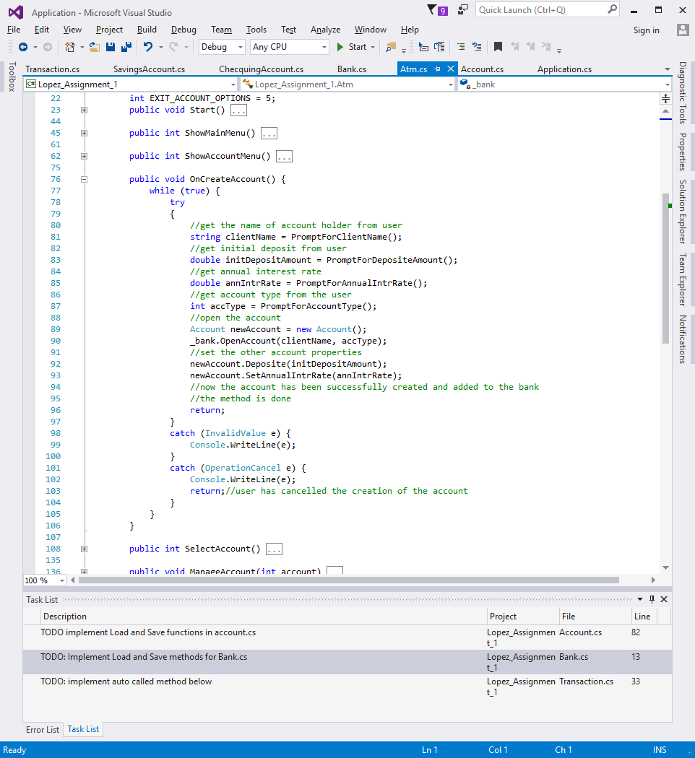
The create account option on the other hand refused to run at all. It seems to be an issue with the createAccount() method. The method seems to be fine but it seems to be that it is not being called correctly.
------------------------------------------------------------------------------------------------------------
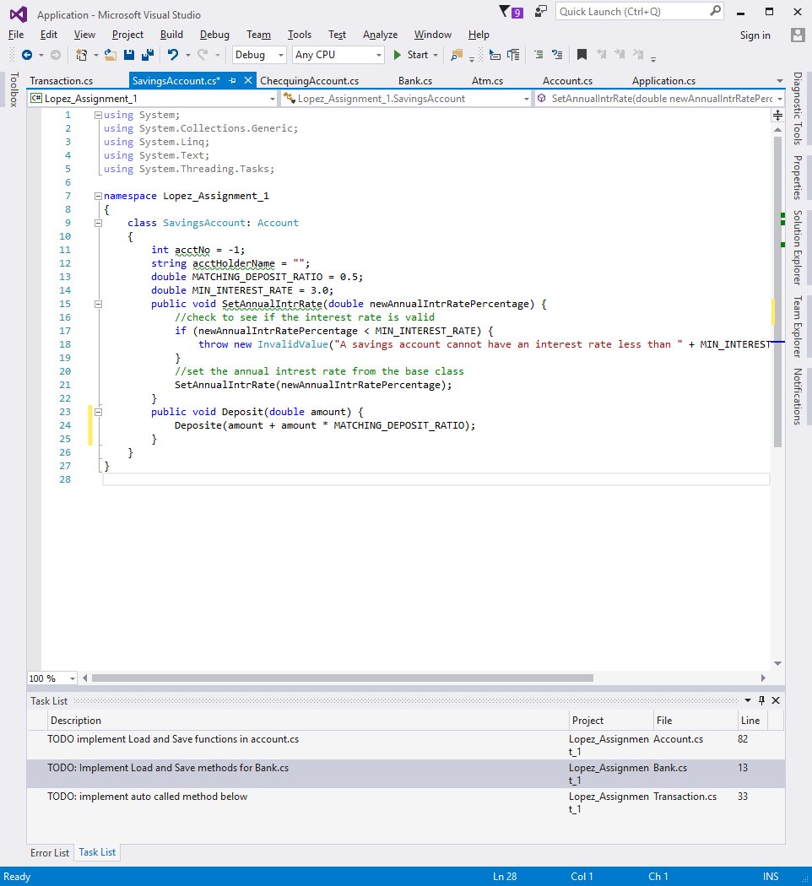
The deposit method (named incorrectly but I noticed far too late into the porting job for it to be viable for me to fix the small spelling error) works exactly as assumed and intended. It takes the value you send it and it adds it, with the already defined interest ratio, into your created bank account.

------------------------------------------------------------------------------------------------------------
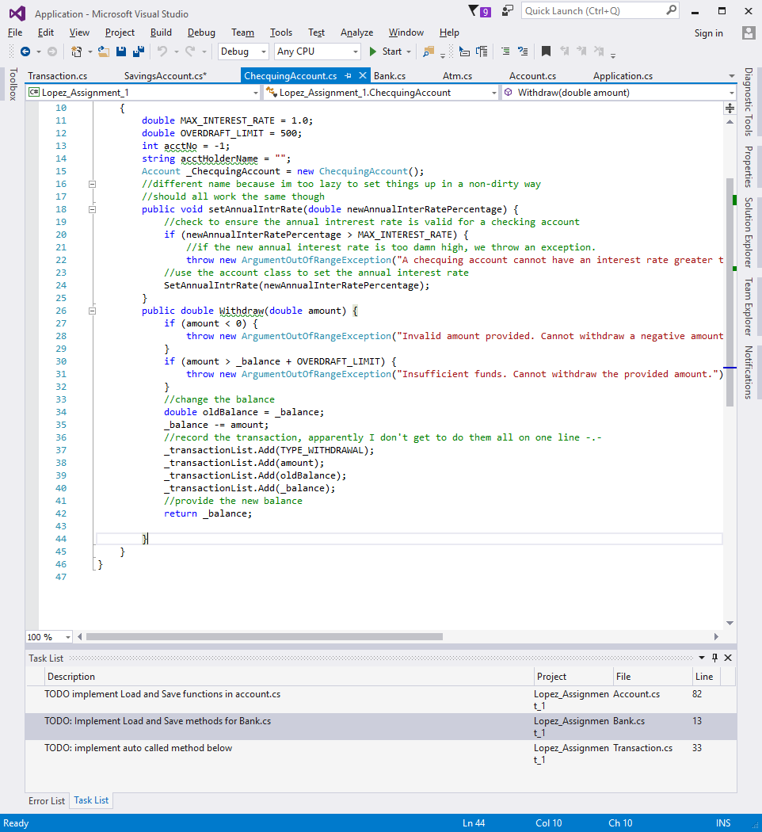
Much like the deposit method, the Withdraw() method worked perfectly fine from what I could tell. It would take the value given and subtract it from the value that is contained in the bank account. If the value is invalid there will be an exception thrown.
------------------------------------------------------------------------------------------------------------
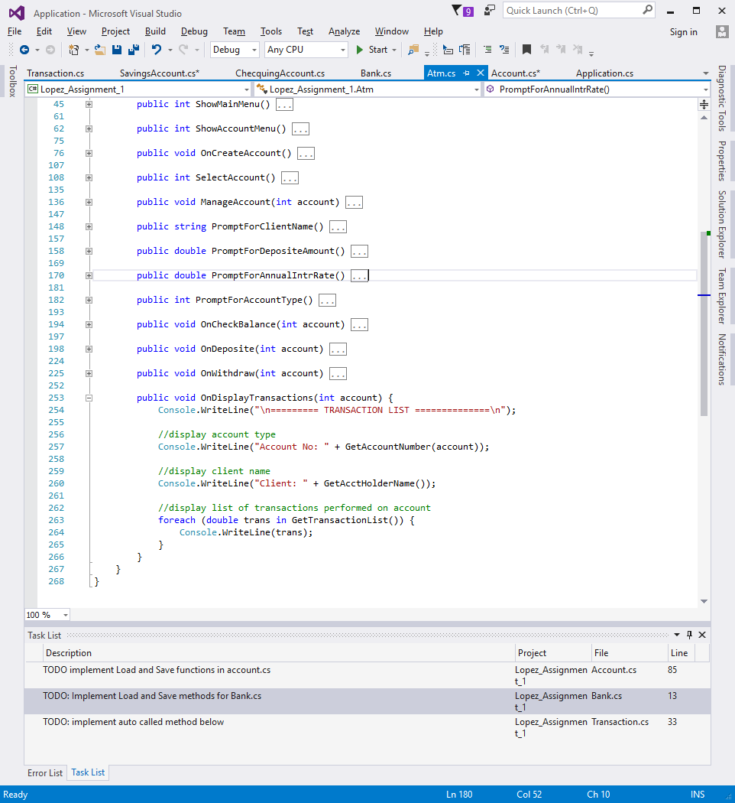
The OnDisplayTransaction() method literally displays the transaction list, one at a time. It seems to work as I’d assumed, but I can not be sure as I have been unable to get to it because of another error in the code that I was unable to fix due to time constraints.
------------------------------------------------------------------------------------------------------------
Part 4 - Statically Typed vs Dynamically Typed Languages:
There’s been a bit of a debate among programmers for a while now as to which type of programming language is superior, if there is one. Both have their uses and benefits, as well as their drawbacks. This paper will seek to discuss these, as well as the features and qualities of each. In this discussion we will be looking at c# as a static example and python as a dynamic example.

To begin with, dynamically typed languages tend to be easier to learn as first languages than their static counterparts. The syntax is generally far more simple and they tend to be more forgiving with variable declaration and overall functionality. For example in python you can literally just declare a variable and then give it any value later on. It will most of the time be automatically converted so you can easily jump between strings, ints and floats. C# on the other hand, is far less friendly. If you declare an integer in c#, lets say for example an integer that has the value of 3. If you then tried to add the value 1.2 to that variable, c# would give you an error, saying that it can’t add ints and doubles. Python on the other hand will just automatically convert the 3 to a 3.0 and make everything work nicely.In static languages you need to convert between types with a command, whereas with dynamic languages you can just do whatever you like with types and things generally just work with little problems raised.
For formatting, Python uses indentation to define blocks of code, while C# uses {} and ; to define when a line or segment of code ends. Once again it comes back to being more forgiving. There will be many times in a new programmers life that he/she will get a whole bunch of errors because they missed a semicolon or a squiggly bracket somewhere in the code. Python on the other hand only formats its code with whites space. If statement contents are indented below the command, code outside of the statement is found unindented. Overall dynamic languages are far less picky than

Python is also interpreted, where c# is not. Everything that is coded in python is run through an interpreter, which analyzes and executes the program line by line. C# on the other hand is translated all at once to binary code and then run. Needless to say, C# is faster in the long run.

Now both languages to tend to have their benefits for different situations. C# is one of the generally accepted languages for professional level programming, for its speed and efficiency. Most professionals will use either C#, C++, C or Java as their language of choice and because of this there is a slew of tools that will make developing with these languages far easier. They are also faster to actually run, although slower to code in. Now python on the other hand is used for a multitude of things. It’s used as an introductory language for high school students who want to learn programming for the first time, as it is fast to program with and easy to read and understand. Professionals at google use to to program quick snippets of code just to see how they work before coding things in the more time consuming languages like C#. Personally I’m somebody that will use both languages, although my mind still defaults to Python, which I expect will change in the coming weeks. I like python because I can write out things quickly just to see how they will go before moving to a language that I’m actually planning to code in. C# on the other hand is the only language I would ever think to use with programming a windows app, since I can have visual studio just automatically generate the user interface and save me loads of time. C# also has the advantage of being widely accepted as a standard by professionals. Due to its efficiency and near universal syntax, it works well as a good overall language to know as well as learn as a first language.

